AIM

Application Functional Design

EETDB Data Entry Tools

Programme: UNIDO EETDB

Author: Nikolay Komissarenko

Creation Date: 20 April 2013

Last Updated: 28 April 2013

Version: 1.0

1. **Title, Subject, Last Updated Date, Reference Number**, **and** **Version** are marked by a Word Bookmark so that they can be easily reproduced in the header and footer of documents. When you change any of these values, be careful not to accidentally delete the bookmark. **You can make bookmarks visible by selecting Tools->Options…View and checking the Bookmarks option in the Show region.**

**Approvals:**

|  |  |
| --- | --- |
| TBD |  |
| TBD |  |
| TBD |  |

1. To add additional approval lines, press [Tab] from the last cell in the table above.
2. You can delete any elements of this cover page that you do not need for your document. For example, Copy Number is only required if this is a controlled document and you need to track each copy that you distribute.

## Document Control

Change Record

| Date | Author | Version | Change Reference |
| --- | --- | --- | --- |
|  |  |  |  |
| 20 April 2013 | Nikolay Komissarenko | 1.0 | draft |
|  |  |  |  |

Reviewers

| Name | Position |
| --- | --- |
|  |  |
|  | Approver |
|  | Reviewer |
|  | Approver |

1. The copy numbers referenced above should be written into the **Copy Number** space on the cover of each distributed copy. If the document is not controlled, you can delete this table, the Note To Holders, and the **Copy Number** label from the cover page.

References

| Document Title | Description | Owner | Location |
| --- | --- | --- | --- |
|  |  |  |  |
| EETDB DB specification | Defines EETDB database structure and code |  |  |
|  |  |  |  |
|  |  |  |  |
|  |  |  |  |

### Contents

Document Control  
 ii

Contents iv

Overview v

Definitions v

Assumptions v

Basic Needs vi

Current state vi

Common requirements vi

EETDB Data Entry tools requirements vi

Tools and technologies vii

EETDB Data Entry Tools architecture viii

Data Entry Tools UI ix

Data Access Layer xxi

Configuration xxii

Deployment xxiv

Open and Closed Issues for this Deliverable xxv

Open Issues xxv

Closed Issues xxv

Appendix A xxvi

1. To update the table of contents, put the cursor anywhere in the table and press [F9]. To change the number of levels displayed, select the menu option Insert‑>Index and Tables, make sure the Table of Contents tab is active, and change the Number of Levels to a new value.

## Overview

### Definitions

EETDB – Energy Efficient Technologies Data Bank

UNIDO – United Nations Industrial Development Organization

DAS – Data Access Services

CRUD – Create, Read, Update and Delete

MVC – Model, View, Controller

REST - Representational State Transfer

### Assumptions

1. EETDB is not a standalone web-enabled system, it’s part of the UNIDO web site <http://energy.unido.ru/>
2. If you use a user-friendly name for this customization as the replacement for <Subject>, the following paragraphs will default nicely.

## Basic Needs

### Current state

At present it is rather difficult to investigate and to describe in detail the whole situation with the energy efficiency management system of Russia on the whole and IEE technology online database systems in particular.

Characterized by a very large geographical distribution, the information on energy efficiency is still scattered and lacks good structuring. Despite the abundance of web sites the databases covering the technology aspect of energy efficiency are rather limited in number. There is apparent lack of structured databanks particularly focusing on energy efficiency/renewable energy technologies, innovations and equipment, i.e. those offering comprehensive industry-specific information which can be utilized by real practitioners – various industrial enterprises planning to introduce energy efficiency improvements.

### Common requirements

EETDB is recommended to opt for the energy efficiency portal with comprehensive and all-inclusive information on energy efficiency rather than a pure technology database which will target only a narrow segment of users.

Content which should be tailored to the information needs of the target audience and encompass different areas of energy efficiency which might be potentially interesting specifically for industries and SMEs. Apart from technology/equipment databases the portal must also include information on legislation/regulations, energy management systems and standards, registers of energy audit and energy service companies, profiles of typical projects implemented in the industrial or SME sector, and other relevant information.

Cross-linkages with other web sites and databases will provide users with access to global resources on energy efficiency (industry data, research papers, articles, documents, case studies and success stories, best practice examples, equipment and technologies).

### EETDB Data Entry tools requirements

EETDB is designed to keep records for any kind of information that can be structured to a form of an article, a document or an entity (for example energy efficient equipment like boilers, heaters etc).

Data Entry Tools is a set of administrative plug-ins to manipulate and manage EETDB data. The tools allow managing either EETDB system data like Entity Templates (entity classes: article, boiler etc. A class is defining a set of properties that entities of this class can have. All entities of the class share same set of properties. For further details see DB Specification) or the data itself (articles, equipment catalogs etc).

Data Entry Tools should provide:

* CRUD operations for both user data and system data.
* Easy to use UI for managing EETDB data.
* Flexibility to extend functionality via pluggable units (screens).

### Tools and technologies

Development tools:

* Java Eclipse
* MySQL Workbench

Platform and technologies:

* Java 1.6
* Spring Framework
* LifeRay Framework
* ExtJS

## EETDB Data Entry Tools architecture

Data Entry Tools are based on LifeRay Framework and actually are Liferay Portlets and so can be pluggable to the main portlet via the LifeRay administrative pages.

Data Entry Tools do not have a direct access to the database and use EETDB Data Access Services to manipulate EETDB data.

## Data Entry Tools UI

The UI is mainly divided into three parts: Entity tools, Topic tools and Entity Templates tools grouped in a toolset tab as depicted below.

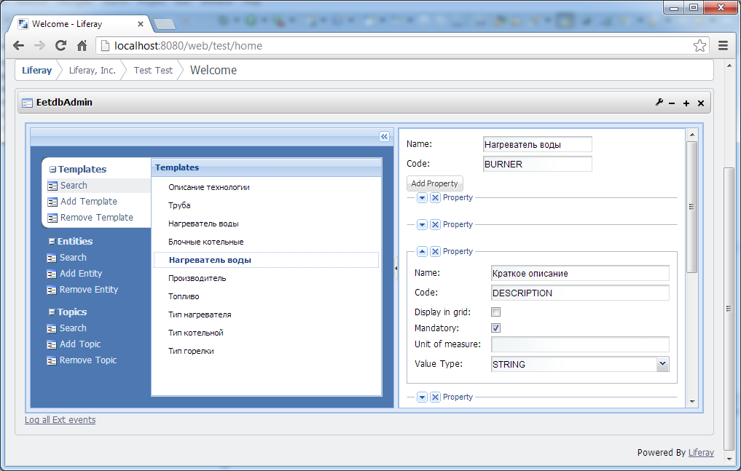

*Pic. 1 General view of the Data Entry Tools*

#### Entity Tools

Allow creating, editing and deleting EETDB Entities such as articles, equipment etc.

Search page allows to search for and find some particular Entity. After selecting one the Entity Properties screen opens at the right side.

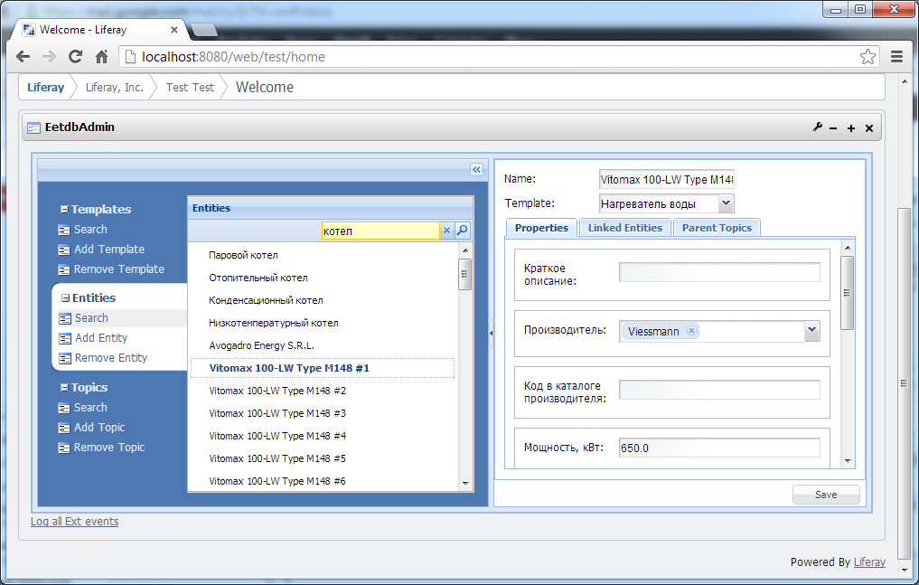

*Pic. 2 Entity Properties screen*

The Entity Properties screen displays all properties that are defined by the Entity's Template, i.e. Entity of the Boiler template will have a different set of properties than the Entity of some other class/template.

This screen allows updating entity properties and change entity linkage. The linkage can be either to another Entity (Parent-Child relationship between entities, for example some Article entities (detailed description or specification) can be linked to a boiler Entity of some type) or to a Topic (general categorization, for example – Cement Industry Equipment).

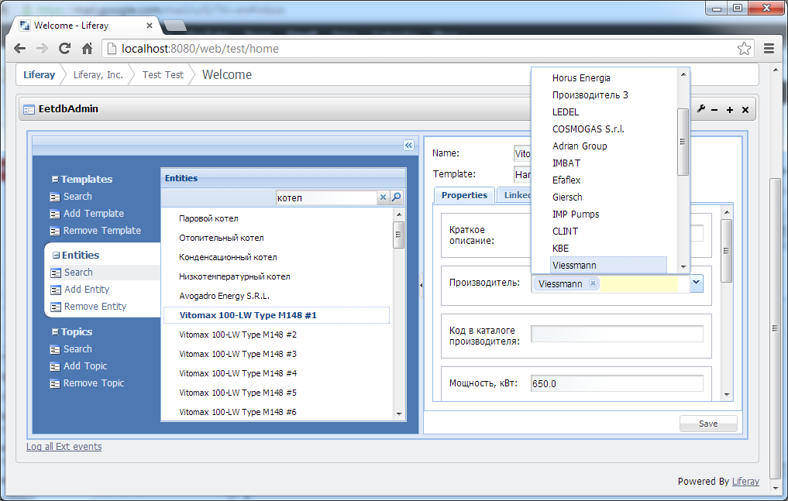*Pic. 3 Changing Entity Properties, for example Vendor*

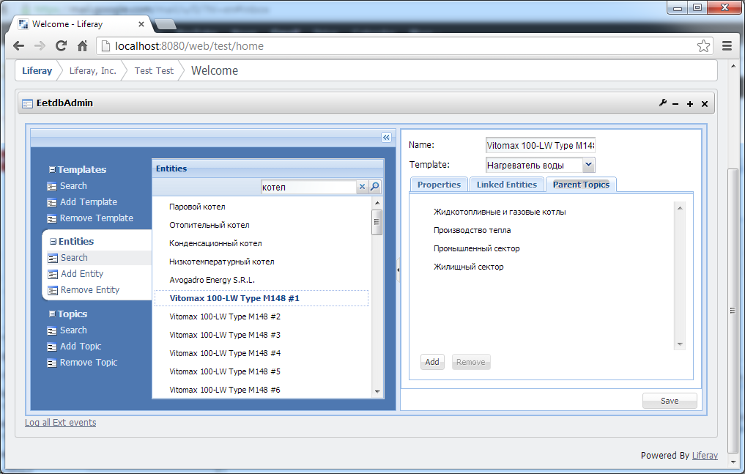*Pic. 4 Entity linkage screen (Topic)*

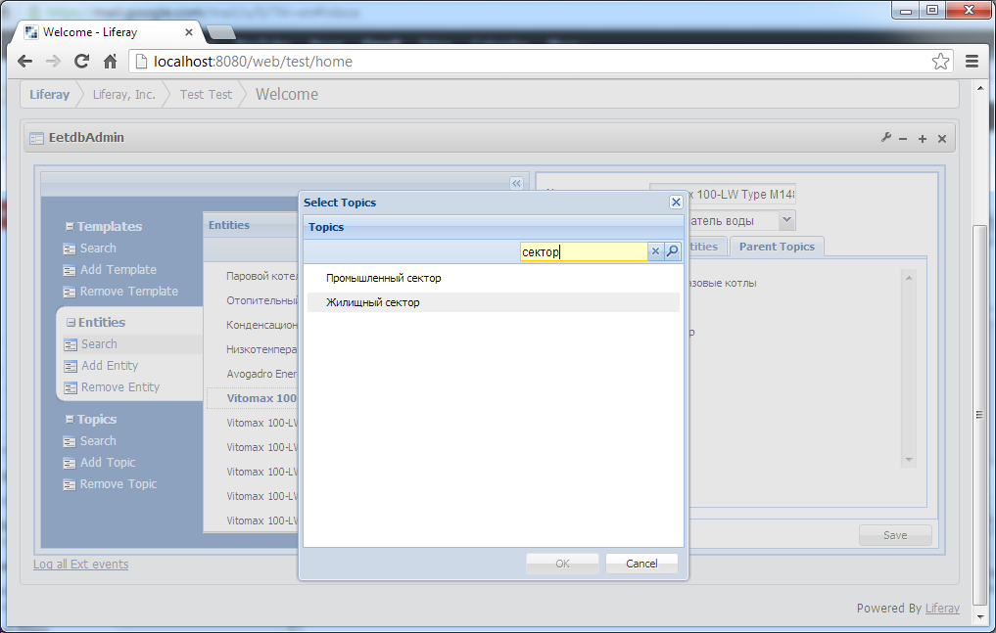

*Pic. 5 Linking Entity to a Topic*

Add Entity tool is for creating a new Entity of some class/template. When opening this screen it's needed to select the Entity Template first. It will define the screen layout in terms of a property set (they are derived from the template). So to add a new Boiler to the EETDB Catalog it's required to select Boiler template and then fill all properties fields.

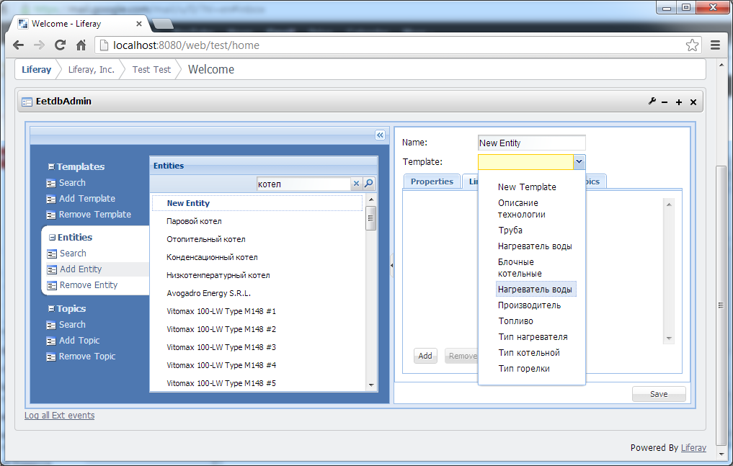*Pic. 6 Selecting the Entity Template for a new Entity*

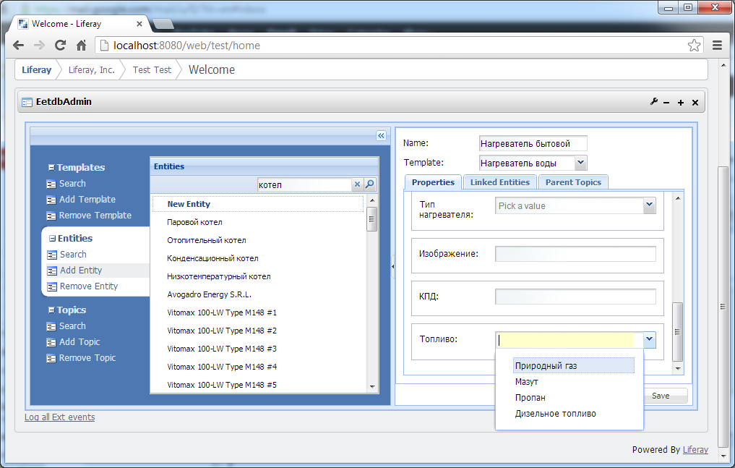*Pic. 7 Filling the Entity's properties*

Remove Entity tool is for finding and deleting Entities that are not needed for storing in EETDB anymore.

#### Entity Template Tools

Entity Template Tools are for defining and amending Entity Templates/Classes available within EETDB. By defining a Template we create a new class for EETDB Entities and all Entities of that class will share the common set of properties (though having different, instance specific values for those properties) defined on the Template level.

Entity Templates allow keeping records in EETDB for any kind of equipment or, in general, any kind of structured information, for example Specifications, External links etc, without making any code or DB changes, just by defining a new Entity Template.

Search tools allow finding or viewing all available Entity Templates. After selecting some particular template it's properties get available for editing on the right side.



*Pic. 7 Entity Template Properties screen*

Add Template is for creating and so defining a new template in the system. First of all it's required to assign an unique Template Code that will be used as a Primary Id for referencing the template.

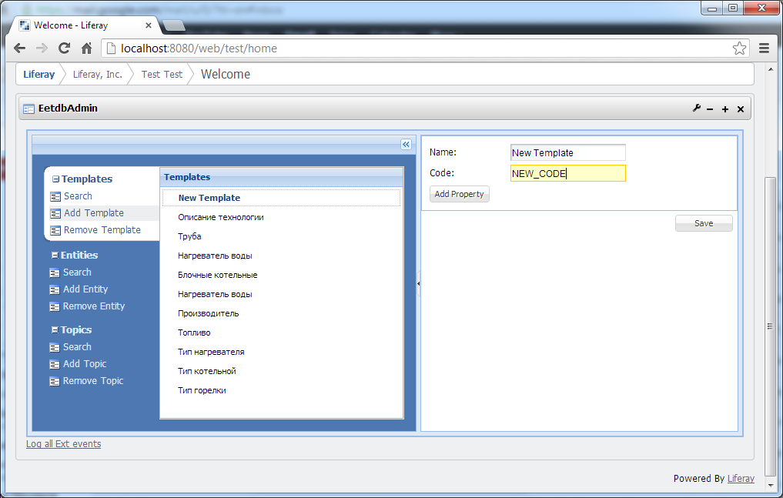

*Pic. 8 Entity Creating a new Entity Template*

After assigning the Code an optional set of properties can be defined for the template. Some templates do not have properties and they are used only for distinguishing some Entities from another. It's mainly used for defining Catalog list items like fuel types (diesel, gas etc), boiler types (condensing boiler, heating boiler etc).

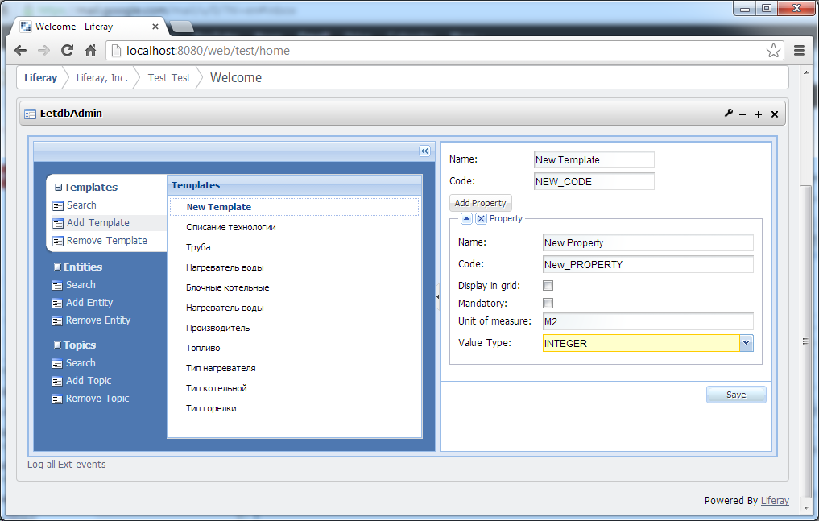

*Pic. 9 Adding a new property to the Entity Template*

For a new property it's possible to define some characteristics:

* **Mandatory** defines if this property a required one for all Entities of the Template. If so, when creating a new Entity via Entity Tools it will be mandatory to enter some value for that property.
* **Display in grid** defines if this property and its value will get displayed in the search results grid on the User UI.
* **Unit of measure** defines what to display in the user UI as the unit of measure for values of that property, for example kilograms or meters per second, etc.
* **Value Type** defines how to treat the values of that property, i.e. if they are numbers or string literals or binary data (documents, images etc). Value Types is a system predefined set of values.

#### Topic Tools

Topic tools help to create and update Topic/Categorization Categories for EETDB. All Entities fall into some general category like Steel Industry Equipment or Agriculture Sector etc. Entities can belong to different Topics depending on a way the Categorization Tree is defined. The system allows as many Topic hierarchies as needed.

For example one of possible Categorizations is depicted below.

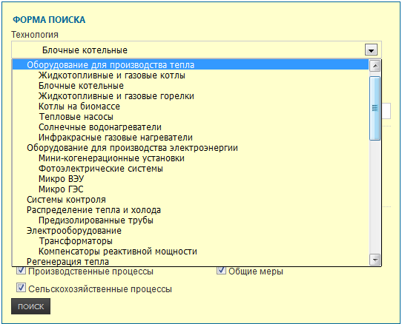*Pic. 10 Equipment Types Topic tree*

Search Tools allow to view all of find a particular Topic from ones defined in the system. By selecting a Topic its properties become available for review and editing on the right pane.

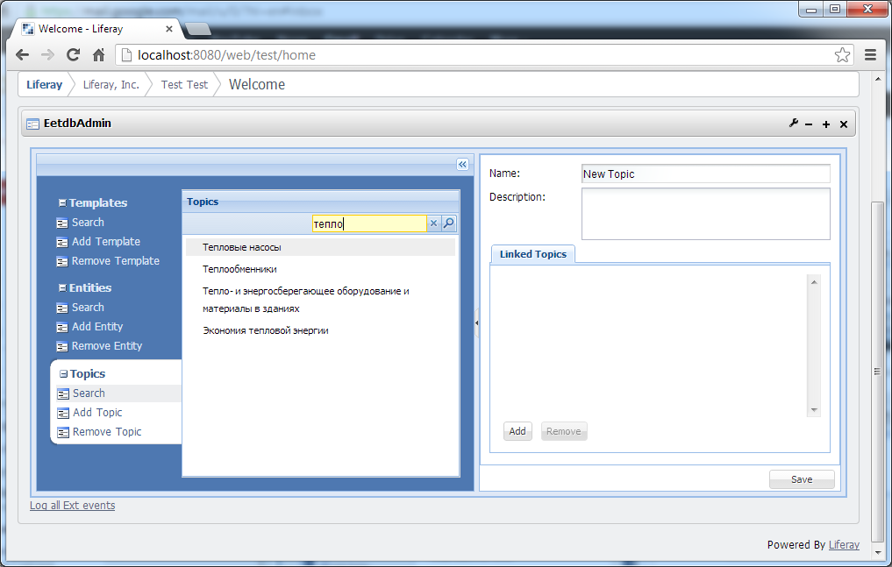*Pic. 11 Searching for a topic*

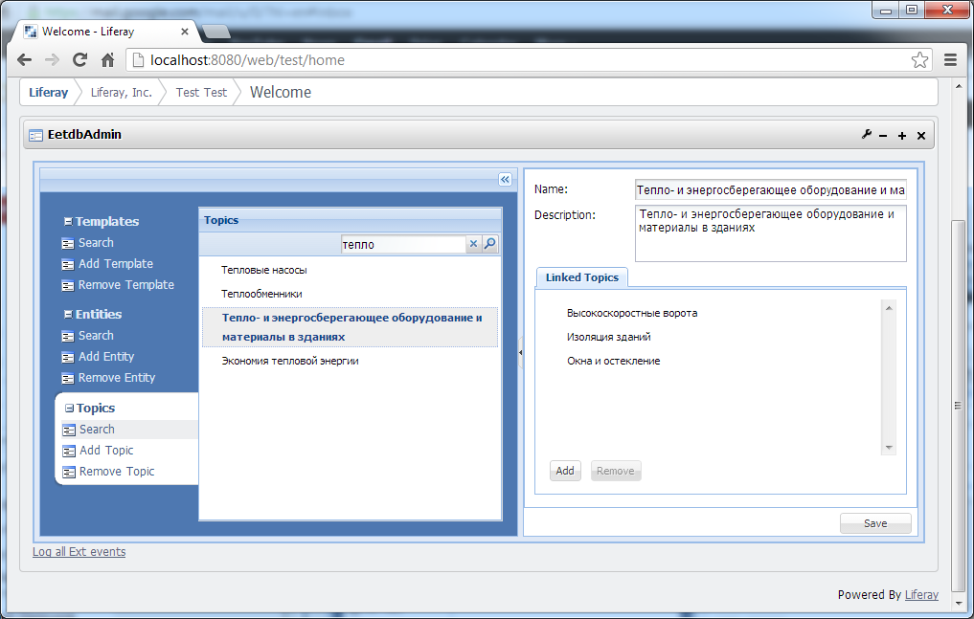*Pic. 12 Selecting a Topic and inspecting its properties*

Generally Topics have no particular properties, apart from Name and Description. The most important part of any Topic is its linkage to other topics. Topics can be linked to each other creating a Topic hierarchy.

Add Topic Tools allow to create a new topic that can spring its own hierarchy or be tied to the existing one.

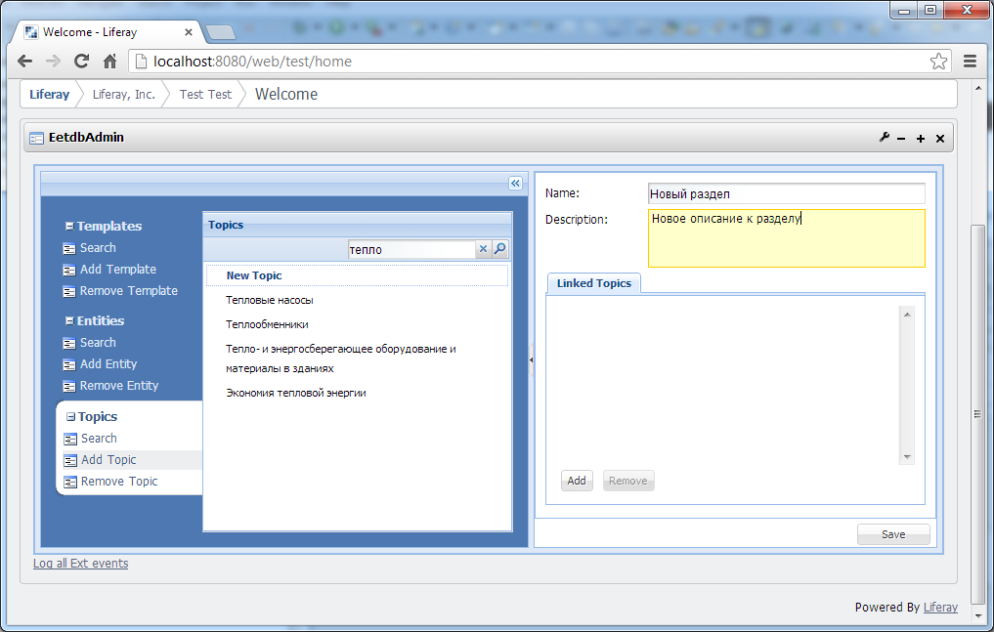

*Pic. 12 Creating a new Topic*

Linking a Topic to other Topics is as simple as finding the Topic to tie to.

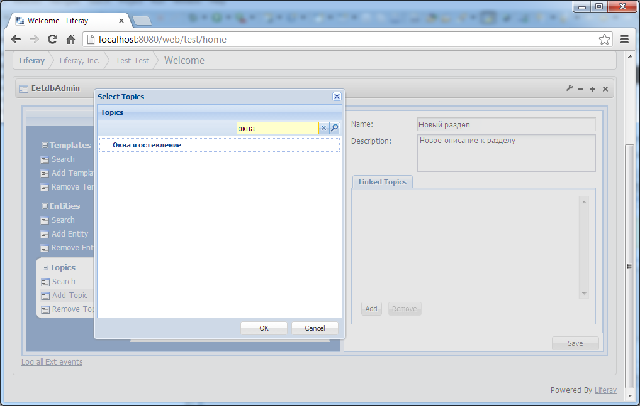*Pic. 13 Linking the Topic*

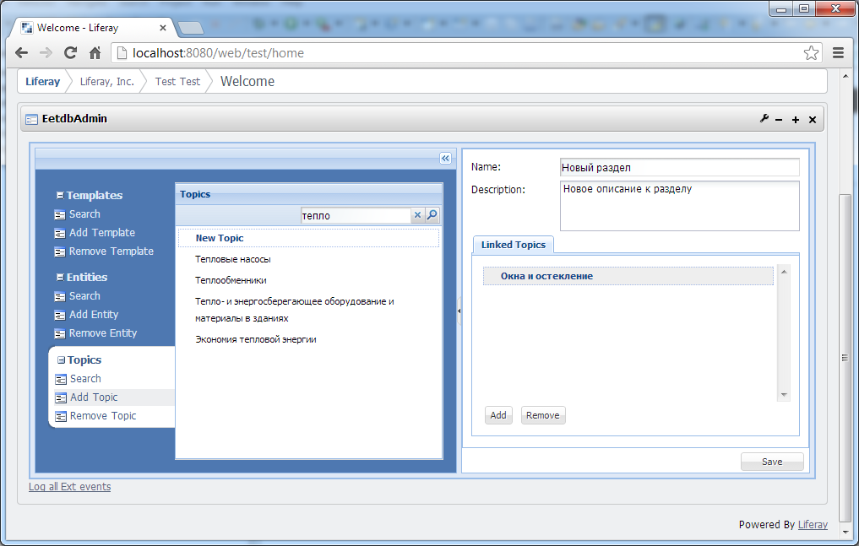*Pic. 14 Newly created Topic linked to some other Topic*

#### Bulk Upload Tools

Bulk upload tools allow streamlining entity entry process. So instead of populating UI fields user can prepare spreadsheet with entity details and feed spreadsheet to system.

One of the possible ways to feed spreadsheet is to use UI to upload file via web. User select **Bulk Upload** menu and hit **Upload Catalog** sub menu item. In popup form user select spreadsheet file from local computer.

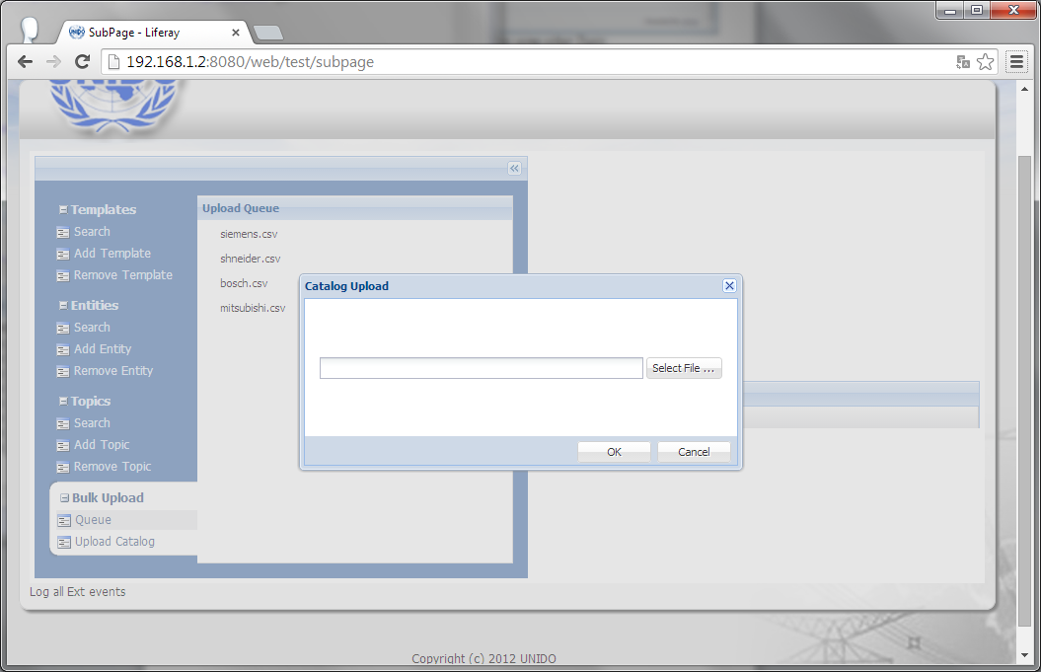

Once uploaded, spreadsheet file appears queued for processing in system

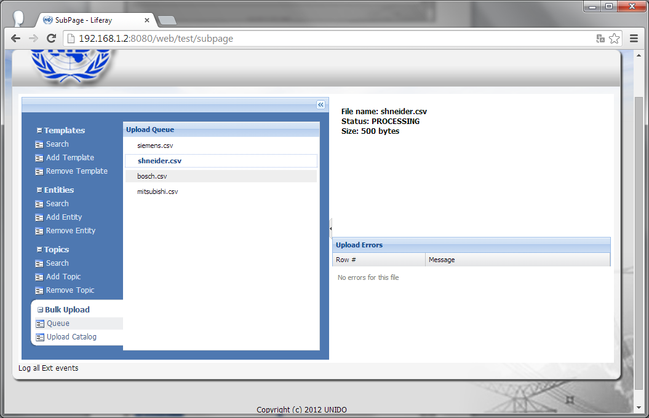

*Pic 15. Spreadsheet file uploaded and being processed by system*

After processing catalog spreadsheet gain either DONE status or ERROR status.

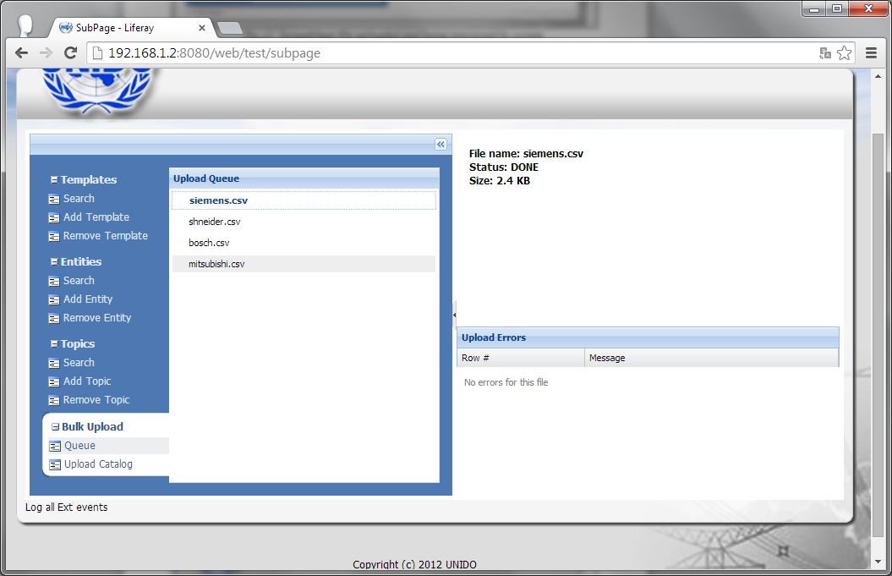

*Pic 16. Spreadsheet file uploaded successfully processed by system*

For spreadsheets in ERROR status it is possible to examine errors occurred so user can fix them for another upload. Errors are displayed per problem row in uploaded spreadsheet file.

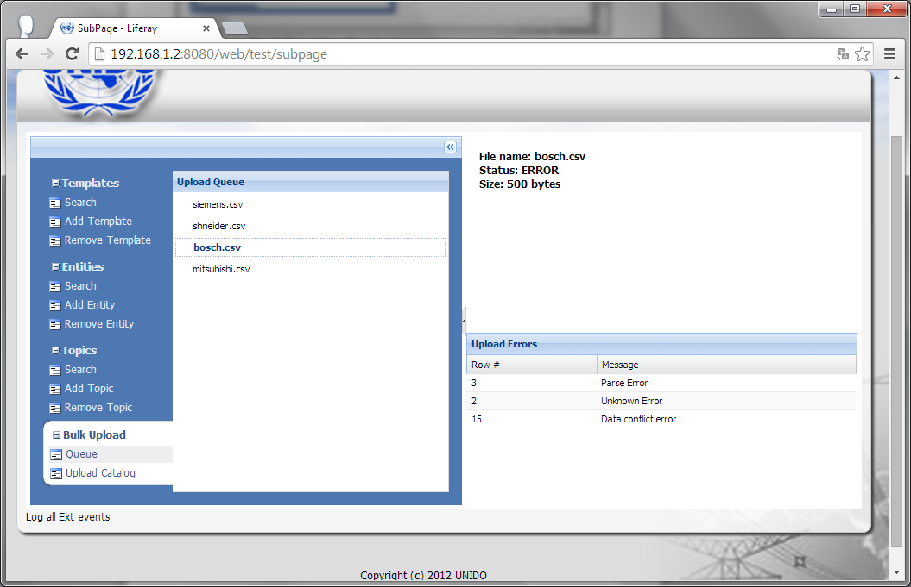

*Pic 17. Spreadsheet file with errors occurred while processing*

## Data Access Layer

Data Entry Tools do not have a direct access to EETDB and uses EETDB Data Access Services accordingly to API they provide to access and manipulate EETDB data.

## Configuration

TBD!

#### Logging

Logging in provided via Log4j and configured via log4j.properties file located in WebContent/WEB-INF/classes folder.

## Deployment

Data Entry Tools are technically Liferay Portlets and distributed in a web archive (WAR) file. Deployment of it is a standard procedure for WARs – the file should be copied in to the Tomcat webapp/ folder and then it will get installed by the server.

After the installation is complete it can be required to update Data Entry Tools config files (ref:Configuration).

## Open and Closed Issues for this Deliverable

1. **Define Auto Cash Rules:** Dell Prepaid Rule, Dell Standard RuleAdd open issues that you identify while writing or reviewing this document to the open issues section. As you resolve issues, move them to the closed issues section and keep the issue ID the same. Include an explanation of the resolution.  
     
   When this deliverable is complete, any open issues should be transferred to the project- or process-level Risk and Issue Log (PJM.CR.040) and managed using a project level Risk and Issue Form (PJM.CR.040). In addition, the open items should remain in the open issues section of this deliverable, but flagged in the resolution column as being transferred.

### Open Issues

|  |  |  |  |  |  |  |
| --- | --- | --- | --- | --- | --- | --- |
|  |  |  |  |  |  |  |
|  |  |  |  |  |  |  |
|  |  |  |  |  |  |  |
|  |  |  |  |  |  |  |
|  |  |  |  |  |  |  |
|  |  |  |  |  |  |  |
|  |  |  |  |  |  |  |
|  |  |  |  |  |  |  |
|  |  |  |  |  |  |  |

### Closed Issues

| ID | Raised by | Issue | Resolution | Owner | Target Date | Impact Date |
| --- | --- | --- | --- | --- | --- | --- |
|  |  |  |  |  |  |  |
| 1 |  |  |  |  |  |  |
|  |  |  |  |  |  |  |
|  |  |  |  |  |  |  |
|  |  |  |  |  |  |  |
|  |  |  |  |  |  |  |
|  |  |  |  |  |  |  |

## Appendix A

**TBD**